SOAP UP + Hand Hygiene/Flu Prevention Social Media Plan

Hand Hygiene
Audience: Public
Facebook:
- Clean hands are happy hands. Learn more about safe hand hygiene at http://mayocl.in/1L9ieoR.
Twitter:
- Clean hands are happy hands! Learn more about safe hand hygiene at http://mayocl.in/1L9ieoR. #SOAPUP
Facebook:
- Germs that cause serious infections are in health care facilities. When you are a patient or visitor, you might get bad germs on your hands from things you touch. Clean your hands often to get rid of these bad germs.https://www.cdc.gov/handhygiene/pdfs/patient-infographic_508.pdf
Twitter
- Germs that cause serious infections are in health care facilities. Clean your hands often to get rid of these bad germs. https://www.cdc.gov/handhygiene/pdfs/patient-infographic_508.pdf
Facebook
- 80% of germs are transferred by touch. Visit http://mayocl.in/1L9ieoR to learn about safe hand hygiene practices.
Twitter:
- 80% of germs are transferred by touch. Learn safe hand hygiene practices by visiting http://mayocl.in/1L9ieoR. #SOAPUP
Facebook:
- Public toilets and door handles harbor all kind of germs. Avoid the spread of germs and use a paper towel to flush the toilet and open the door. Be sure to throw the towel away after you leave. Learn more about stopping the spread of germs at http://mayocl.in/1L9ieoR.
Twitter:
- Use a paper towel to flush the toilet and open the door in public restrooms because of the germs they harbor. Throw the towel away after you leave. Learn more about safe hand hygiene at http://mayocl.in/1L9ieoR.

Facebook
- If soap and water are not available, use an alcohol-based hand sanitizer that contains at least 60 percent alcohol to protect yourself from germs! http://consumers.site.apic.org/infection-prevention-basics/wash-your-hands-often/
Twitter
- If soap and water are not available, use an alcohol-based hand sanitizer that contains at least 60 percent alcohol to protect yourself from germs! #HandHygiene #PatientSafety http://consumers.site.apic.org/infection-prevention-basics/wash-your-hands-often/

Audience: Both health care providers and the public
Facebook:
- A trick to making sure you’re washing your hands long enough is to sing “Happy Birthday” twice as you rinse your hand with soap and warm water.
Twitter:
- DYK, you can make sure you’re washing your hands long enough by singing “Happy Birthday” twice as you wash your hands? #SoapUP
Facebook:
- When you’re washing your hands, be sure to cover all areas of your hand with soap: fingers, wrists, fingernails and the back of the hand. Visit The Association for Professionals in Infection Control and Epidemiology’s site for more tips: http://consumers.site.apic.org/infection-prevention-basics/wash-your-hands-often/
Twitter:
- When you’re washing your hands, make sure you’re washing them completely: fingers, wrists, fingernails and the back of the hand. Visit APIC for more tips http://consumers.site.apic.org/infection-prevention-basics/wash-your-hands-often/

SOAP UP Social Media
Audience: Health care providers
Facebook:
- One of the best ways to keep patients safe is to practice proper hand hygiene. Check out our SOAP UP resource page for all your hand hygiene information needs!
  - 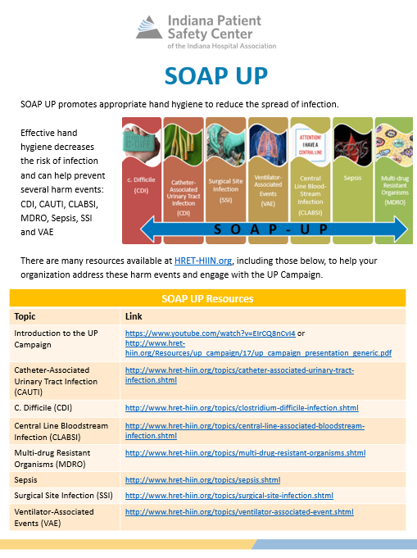
  - 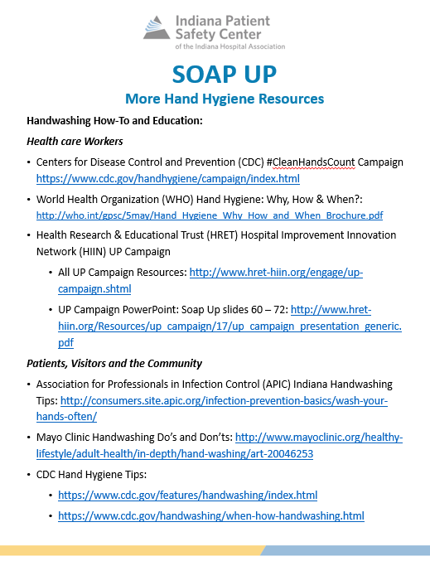
Twitter:
- One of the best ways to keep patients safe is to practice proper hand hygiene. Check out our SOAP UP resource page! #SOAPUP

LinkedIn:
- IHA is hosting four SOAP Up Hand Hygiene Webinars throughout the summer. Join as for as many as you can to learn more about hand hygiene and how it can help keep patients safe in Indiana:
- 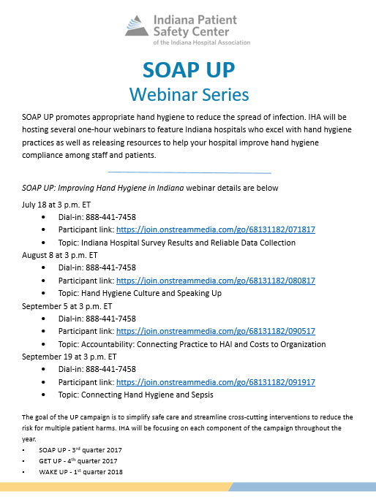
Facebook:
- Place hand hygiene products close to a sink or in an area that others will be able to readily see and utilize them. For more information on the SOAP UP Campaign, visit http://www.hret-hiin.org/engage/up-campaign.shtml

Twitter:
- Place hand hygiene products in strategic locations where others will readily see and utilize them. Visit http://www.hret-hiin.org/engage/up-campaign.shtml for more information. #SOAPUP

Facebook:
- Own your role in preventing hospital acquired infections. Do your part in reducing the spread of infection by holding yourself accountable to practice appropriate hand hygiene. Visit http://www.hret-hiin.org/engage/up-campaign.shtml for more about the SOAP UP Campaign.
Twitter:
- Own your role in preventing hospital acquired infections by holding yourself accountable to practice safe hand hygiene. Learn more about the SOAP UP Campaign at http://www.hret-hiin.org/engage/up-campaign.shtml #SOAPUP
Facebook:
- Update hand hygiene products policies as needed to promote adherence. For more information on the SOAP UP Campaign, visit http://www.hret-hiin.org/engage/up-campaign.shtml.
Twitter:
- Update hand hygiene product policies to promote adherence. For more information, visit http://www.hret-hiin.org/engage/up-campaign.shtml #UPCampaign #PatientSafety
Facebook:
- Protect patients by involving them and their families in hand hygiene practices. Parents and families are key to promoting and reducing the spread of infection with good hand. Learn more at http://www.hret-hiin.org/engage/up-campaign.shtml.
Twitter:
- Protect patients by involving them and their families in hand hygiene practices. Learn more at www.hret-hiin.org/engage/up-campaign.shtml. #UPCampaign #SOAPUP

Audience: Public
Facebook:
- As a patient or visitor at a hospital, you have a role in preventing the spread of germs that cause serious infections. Clean your hands often while you are a patient or visiting someone in a health care facility. http://www.hret-hiin.org/engage/up-campaign.shtml
Twitter:
- As a patient or visitor at a hospital, you have a role in preventing the spread of germs that cause serious infections. Clean your hands often while you are a patient or visiting someone in a health care facility.

Audience: Both health care providers and the public
Facebook:
- Be sure to scrub your hands for 20 seconds with warm water and soap. To learn more about the SOAP UP Campaign, visit http://www.hret-hiin.org/engage/up-campaign.shtml #SOAPUP
Twitter:
- Be sure to scrub your hands for 20 seconds with warm water and soap. To learn more about the SOAP UP Campaign, visit http://www.hret-hiin.org/engage/up-campaign.shtml #SOAPUP
Facebook:
- Speak UP for clean hands. For more information on the SOAP UP Campaign, visit http://www.hret-hiin.org/engage/up-campaign.shtmlv.
Twitter:
- Speak UP for clean hands. For more safe hand hygiene practices, visit http://www.hret-hiin.org/engage/up-campaign.shtml #SOAPUPforSafety #SOAPUP

