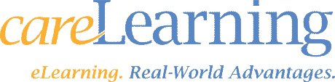
LIVE PRODUCT INFORMATION WEBINAR
Date: September 30th 2020 | Time: 11am Eastern Standard Time
Duration: 60 Minutes | Instructor: Tony Wegmann
Location: Online

Webinar Overview:
In this webinar you will gain practical knowledge of how the careLearning system will help you organize and manage your education. careLearning is non-profit member service of The Indiana Hospital Association and over 40 other state hospital associations.
Areas Covered in the Session:  - Discover who careLearning is and what we have to offer your organization such as an award-winning Learning Management System, Full course catalog specific for healthcare, Competency Management, Performance Management, and much more.  - Learn how our system will assist you in effectively managing both online and live education  - Maximize course offerings for your employees in a cost and resource effective way  - Witness how easy and comprehensive the documentation and reporting will make your next performance evaluation or audit.  - See the ways that education is centralized so that employees and managers can easily find out what education is required or available  - Discuss the implementation process and product support  - Ask questions of a careLearning Product Expert | Who will benefit:  Anyone who has a vested interest in providing education to employees. This might include:  - Staff Educators  - Human Resources  - Nursing Executives or Managers  - Compliance Officers  To Register:  Contact Tony Wegmann at twegmann@carelearning.com  or call 304-353-9754.

