Designed specifically for healthcare marketing and public relations professionals, the Indiana Healthcare Strategic Communications Summit 2017 will equip you with the tools you need to transform your marketing and communications efforts. The Summit is brought to you by the Indiana Hospital Association and the Indiana Healthcare Marketing and Public Relations Society.
Join your peers on August 24 and 25 to discover new trends and strategies and hear from nationally renowned healthcare marketing and communication experts. The Summit will be held at The Reserve at Hamilton Trace on Aug. 24 and St. Vincent Fishers on Aug. 25. At the end of the conference on Friday, Aug. 25, attendees have the option to attend a tour of St. Vincent Fishers, located at 13861 Olio Road, Fishers, IN 46037.
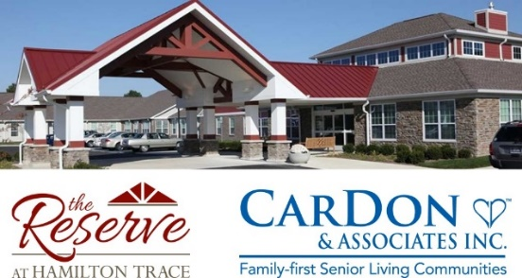
Don’t forget to join us Aug. 24 for an evening of networking and food at local brewery Four Day Ray in Fishers. We hope to see you there!
THURSDAY, AUGUST 24
The Reserve at Hamilton Trace
11851 Cumberland Road, Fishers, IN 46037

9 – 9:30 a.m. // Registration and Continental Breakfast
9:30 – 9:45 a.m. // Welcome and IHMPRS Presentation
Terri Christiansen, Marketing Director & Public Information Officer, DeKalb Health
IHMPRS President
9:45 – 10:45 a.m. // CarDon & Associates Presentation and Tour
Speakers from CarDon & Associates will present on the innovative work they have been doing at their facility, The Reserve at Hamilton Trace, with senior living and care.
10:45 – 11:15 a.m. // Introductions and Show & Share
Each attendee will have the opportunity to share a project or campaign they’ve been working on over the past year. We hope this provides not only an opportunity to show off your hard work, but also an opportunity for better networking and sharing of information.
11:15 a.m. – 12:15 p.m. // The State of our Health
Dr. Paul Halverson, Founding Dean of IUPUI Fairbanks School of Public Health
12:15 – 1:30 p.m. // Lunch and Alliance for a Healthier Indiana Presentation
Jennifer Hurtubise, Vice President of Communications, Indiana Hospital Association
Laura McCaffrey, Public Affairs Specialist, Indiana Hospital Association

Register Online: Regonline.com/IHMPRS17

1:30 – 2:30 p.m. // Leading in a Changing Work Environment
Sara Johnson, FACHE, Director of Executive Education, Clinical Assistant Professor, IUPUI School of Public and Environmental Affairs
Leading in the dynamic healthcare environment is challenging. With multiple generations making an effort to understand each other and work together, everchanging technology and the continuation of new and changing “rules” for our industry, it’s no wonder everyone around us seems stressed! We will discuss ways leaders can help their teams not only work together, but stay focused and succeed, in the middle of what, at times, seems like sheer chaos.
2:30 – 3 p.m. // Hospital Show & Share
Each attendee will have the opportunity to share a project or campaign they’ve been working on over the past year. We hope this provides not only an opportunity to show off your hard work, but also an opportunity for better networking and sharing of information.
3 – 4 p.m. // Parkview Health - Failure to Launch
How United Airlines’ failed crisis communications plan grounded the company’s reputation
Eric Clabaugh, Parkview Health Director of Communications
Jessica Miller, Parkview Health Public Relations Manager
Crisis communications is by definition a carefully designed plan with the intent to protect an organization during a public relations crisis. Using lessons learned from United Airlines’ recent crisis, Clabaugh and Miller will discuss communications tactics and reputation management for healthcare professionals. With more than 20 years of combined experience in public relations, communications and journalism, the two will offer insight into what’s needed for a crisis communications plan and how you can begin preparing one for your organization.
6 p.m. // Dinner/Networking Event at Four Day Ray
11671 Lantern Road, Fishers, IN 46038
Join your colleagues for a night of dinner and networking at the local brewery Four Day Ray. Dinner and drinks are already included in your registration fee, so you will be able to enjoy the evening and share ideas with innovative leaders from across the state.

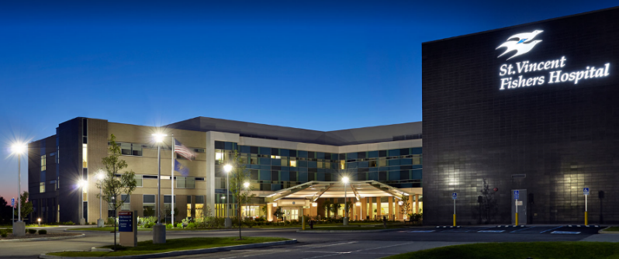
FRIDAY, AUGUST 25
St. Vincent Fishers
13861 Olio Road
Fishers, IN 46037

8 - 9 a.m. // Continental Breakfast
9 - 10 a.m. // St. Vincent Welcome and Social Media Presentation
“Social Media Did You Know?”
Dan Rench, R.N., B.S.N., M.S., M.B.A., System Director Digital Services, St.Vincent Indiana Ascension
Selina Bradley, Digital Specialist, St.Vincent Indiana Ascension

10 - 11 a.m. // American Hospital Association: Healthcare Reform & Federal Update
Heather Drevna, Vice President, Advocacy & Member Communications
American Hospital Association
With repeal and replace legislature coming from both parties, the fate of the ACA is uncertain. Heather Drevna will discuss how the repeal could affect different sectors of healthcare.
11 - 11:15 a.m. // Closing Remarks from IHMPRS President
Terri Christiansen, Marketing Director & Public Information Officer, DeKalb Health
11:15 a.m. – 12 p.m. // St. Vincent Fishers Hospital Tour

Sponsorship Opportunities Available!
Learn more about becoming a Sponsor at IHMPRS.org or email IHMPRS President Terri Christiansen at tchristiansen@dekalbhealth.com.

REGISTRATION

Register Online: Regonline.com/IHMPRS17

Registration Fees
- $300 – This includes membership dues for the following year
2017 conference attendees will receive a discount to attend the 2018 conference
- $200 – 2016 Conference Attendee rate
*Food and drinks are included in your conference fees

Payment Options

Payments can be made online by credit card (preferred) or by check
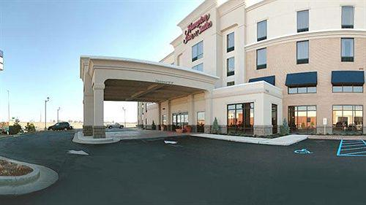

Hotel Information

Hampton Inn & Suites
11575 Commercial Drive Fishers, IN 46038

Book by calling the hotel at 317-913-0300. Please note that we do not have a room block or special pricing.

Questions? Contact IHMPRS President Terri Christiansen at tchristiansen@dekalbhealth.com or IHA Vice President of Communications Jennifer Hurtubise at jhurtubise@IHAconnect.org.

Cancellation & Refund Policies

Registration deadline is July 14. For cancellations made on or before July 14, a fee will be retained. Refunds will not be issued for cancellations made after July 14. Substitutions are permitted and can be made online.

Individuals with Disabilities

Indiana Hospital Association wishes to take the steps required to ensure that no individual with a disability is excluded, denied services, segregated or otherwise treated differently from other individuals because of the absence of auxiliary aids and services.

